Web-design Project 2023

[S00237040@atu.ie](mailto:S00237040@atu.ie)

Student number: S00237040

Name: Oisin Duffy

GitHub link:[Oisin-Duffy/webdesign-project-2023: webdesign project (github.com)](https://github.com/Oisin-Duffy/webdesign-project-2023)

Webpage:[**https://oisin-duffy.github.io/webdesign-project-2023/**](https://oisin-duffy.github.io/webdesign-project-2023/)

Initial proposed sketch

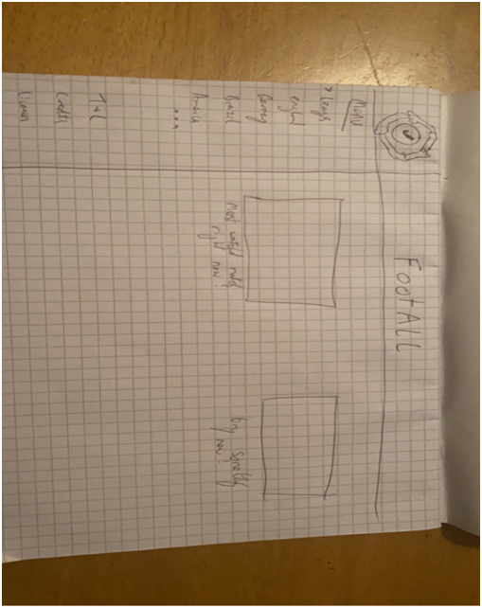

Check list

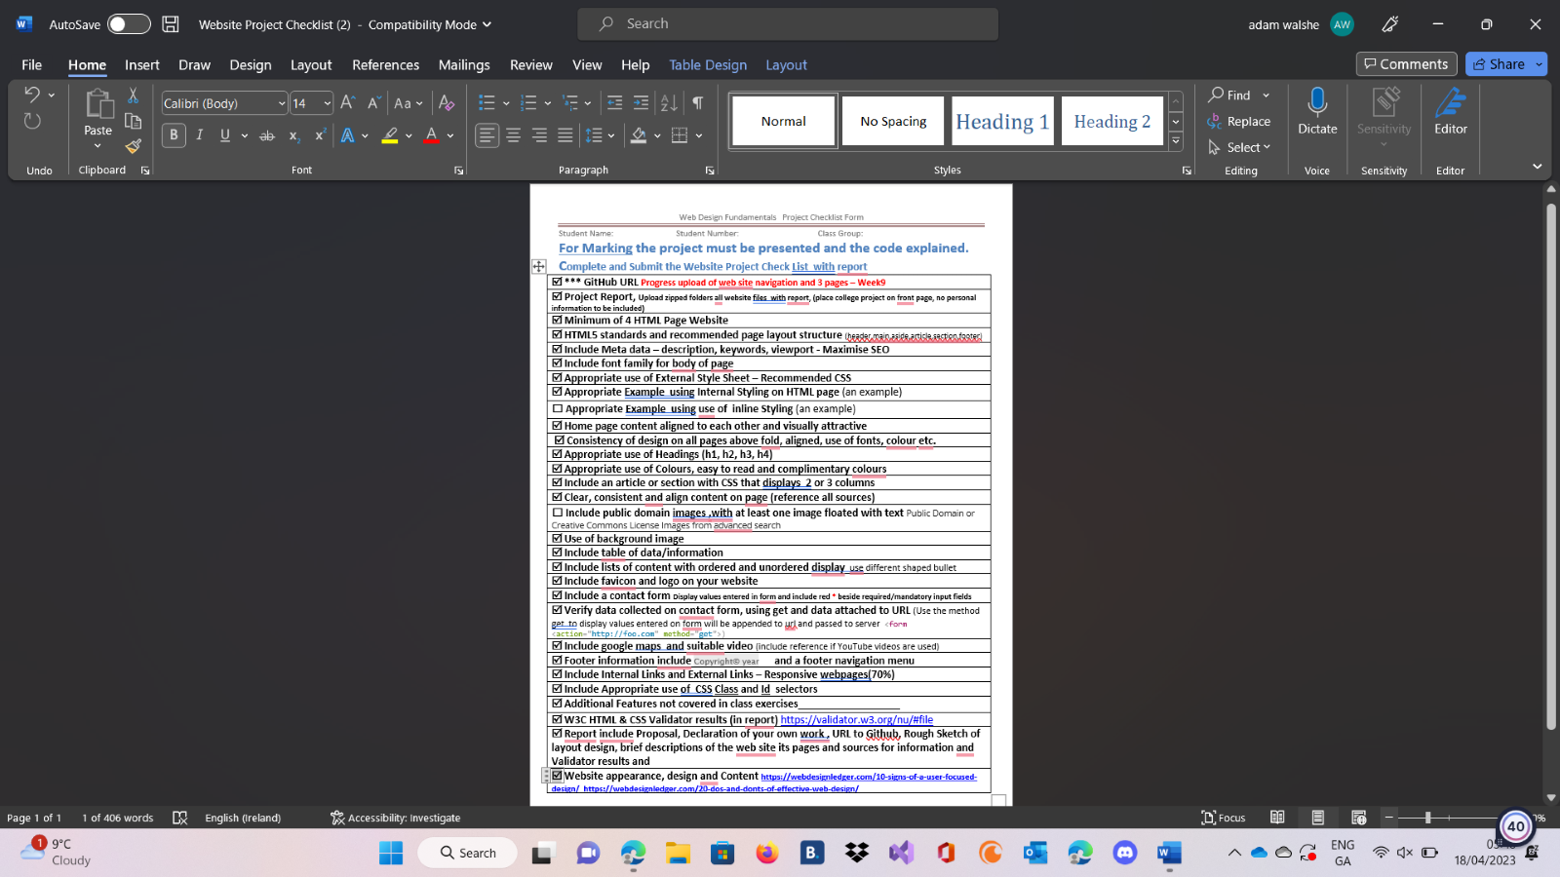

Index

This is the home page that explains how my website works and gives some information on the man who created the company. This page also gives insight into the company and where it came from and where it is now. I think the home page is important to catch the viewers' attention and explain what the website does and is about

Sales

This page talks about and shows the sales the website has and how they rotate every week depending on real world matches. This page gives both visual and text about said sales showing an image of the jerseys on sale and explain the position the team is in and how important the match is.

Buy Now

This is the most important page on the site as it shows all the codes for the jerseys that one can buy and also the prices of the jerseys in a concise table while also showing what jerseys are on sale and this page also has the forum to fill out for the details for the product and billing and shipping.

Jersey Display

This page shows some of the jerseys that are currently most popular on the site showing both home (right image) and away (left image) jerseys. This page also has a link to a site with multiple jerseys on it to showcase the jerseys for those unaware of what ones they want to buy.

More Information

This page gives extra information if in need of contacting the company and also give information on FAQs, size guide, a google map, a YouTube video showing off a shirt collection and a return policy for the company.

Validation

index

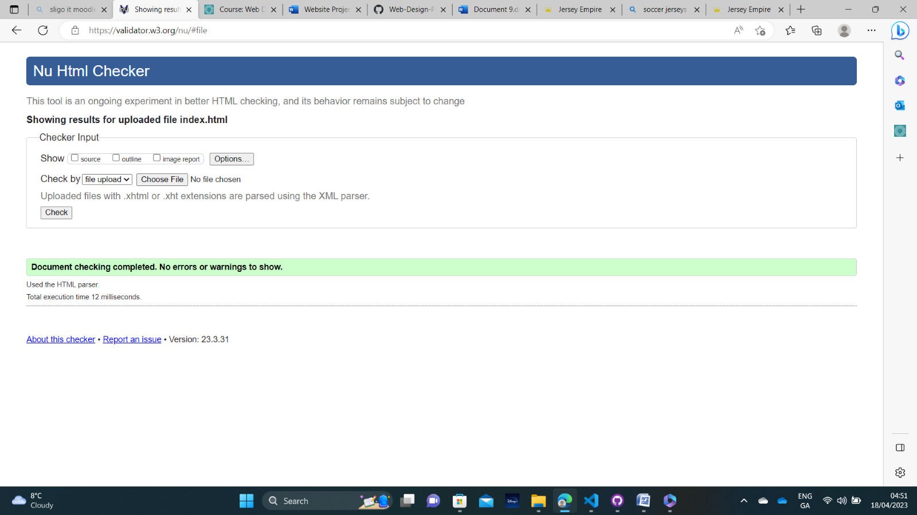

Sales

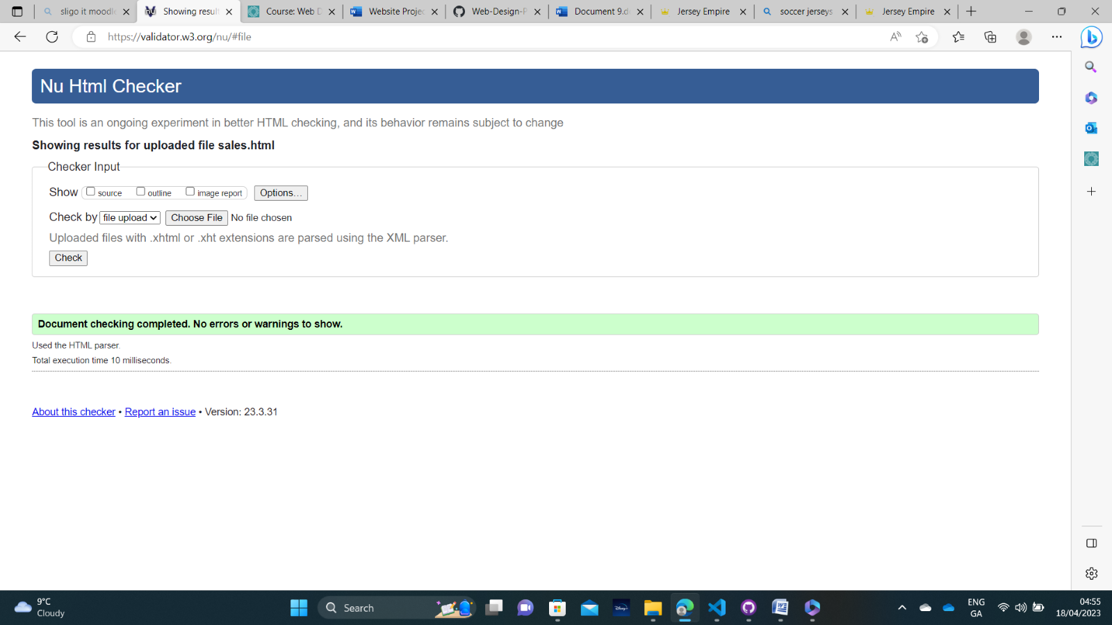

Buy now

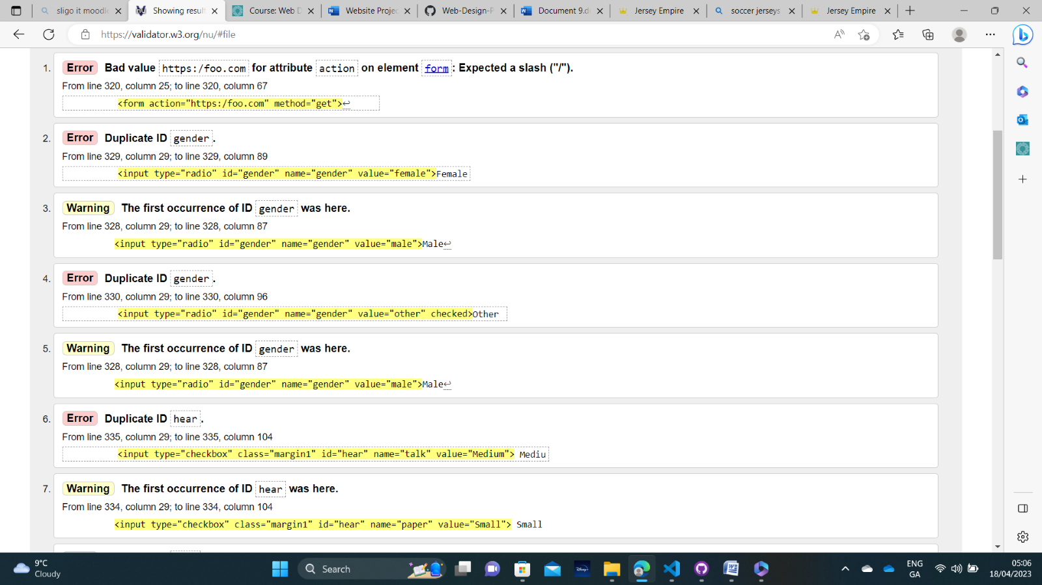

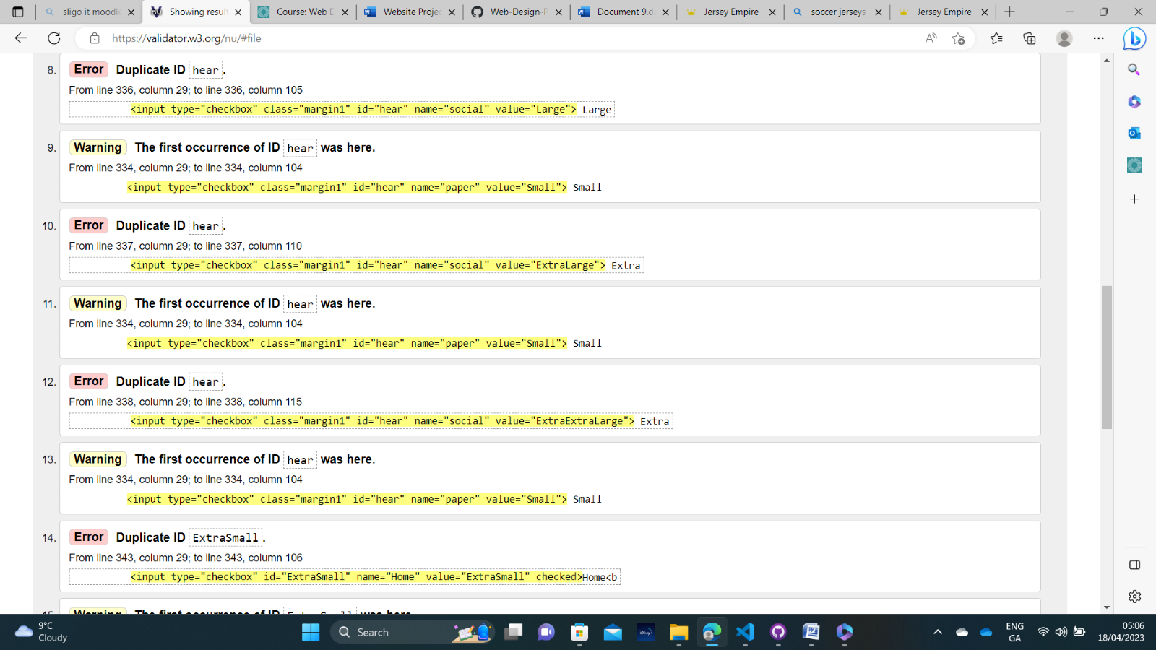

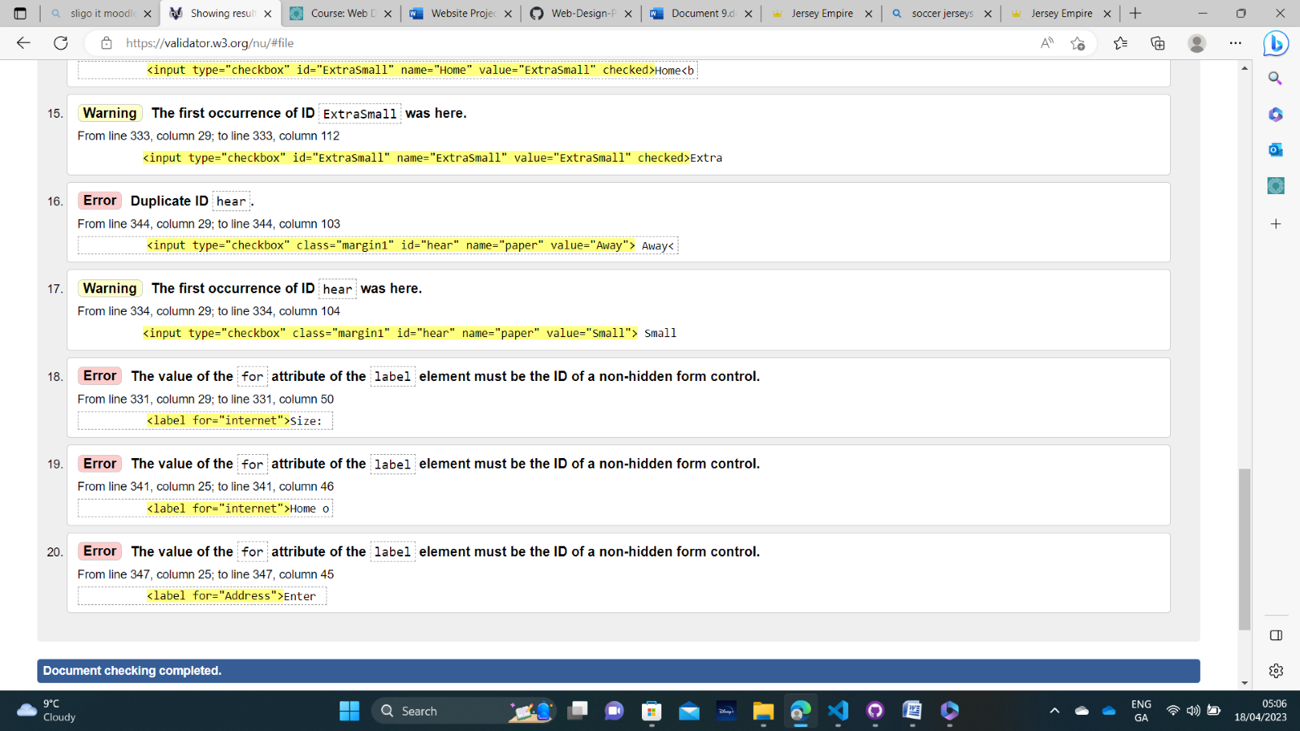

Errors regarding duplicates of ids or classes was done on purpose for the use of style sheet code multiple times and I do not believe these to be errors

Jersey Display

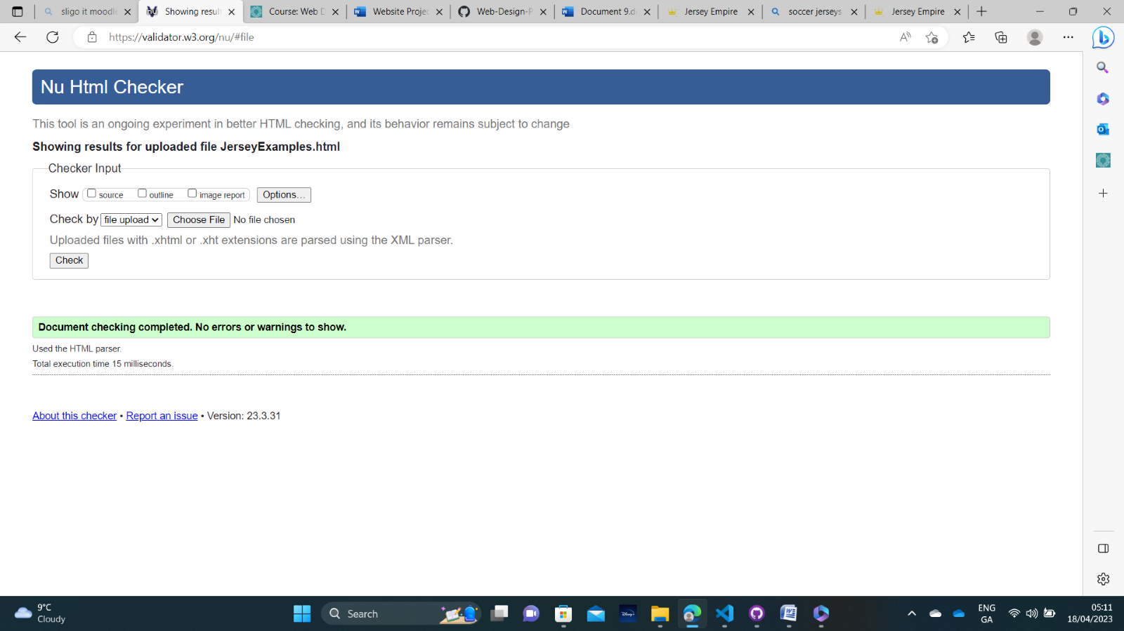

More Information

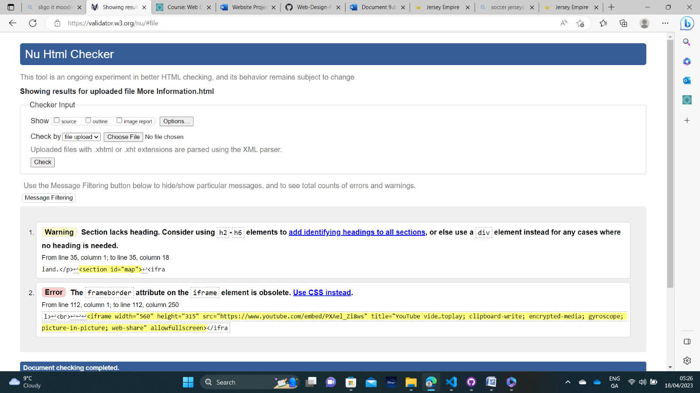

Style sheet

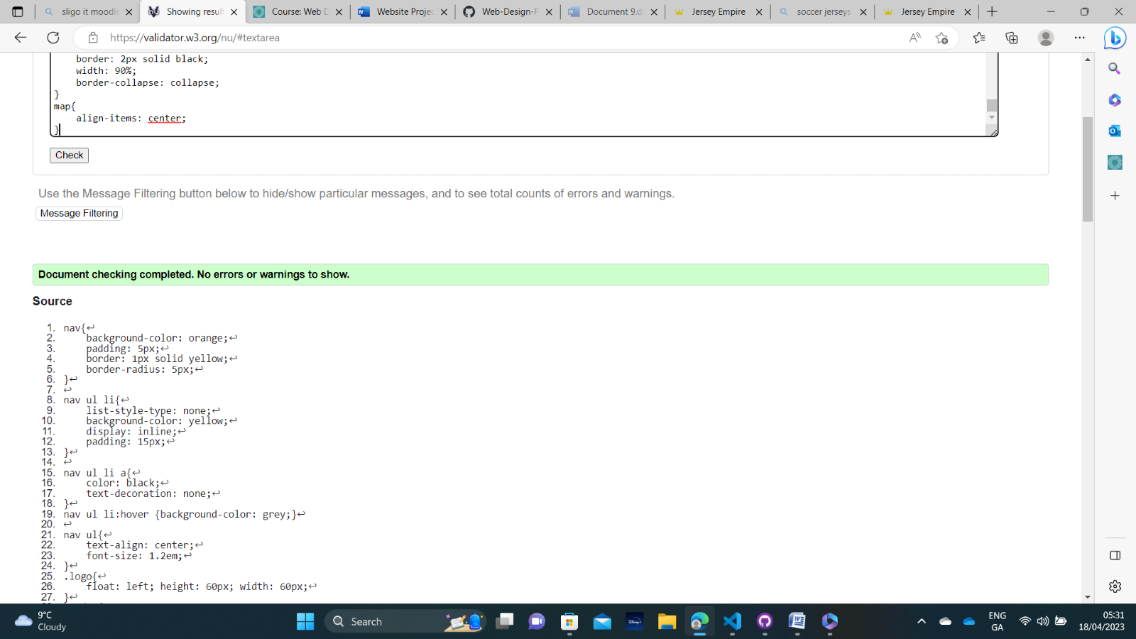

Declaration of own work

